Third Person Controller Base 1.00.00
Third Person Controller Base is a set of scripts to let you program the basics of a TPS following basic SOLID concepts. Third Person Controller uses Unity Character Manager to control the player movements, and Cinemachine to control the camera.
It means that the control is by itself completely modular and easy to change, adapt, and to add the behaviors needed in your game.
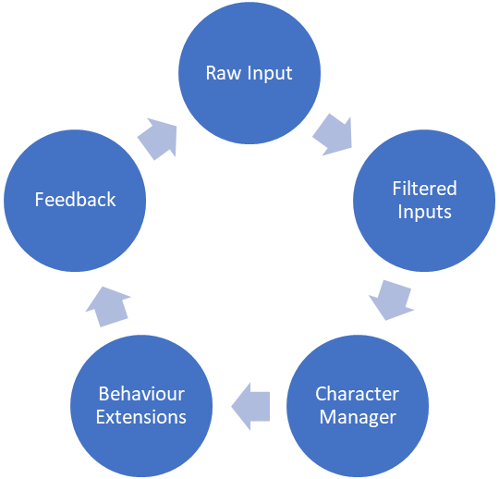
Figure 1TPS Workflow
Apart from the demo, we provide the main character manager and a basic set of behavior extensions, that allows your player to:
- Camera rotation
- Walk
- Run
- Jump
- Ground detection
- Be affected by gravity
- Fall
- Fall from edges
The Raw input, the Filter Inputs, and the Feedback is all on your side. Don’t worry. The basic example shows you how it all works.

Basic concepts
TPC is based on 4 pillars:
- CharacterManager: It is the main component of this solution, and it manages everything. In the inspector you will see it almost empty, except for the “Add Extension” selector.
- CharacterExtension: The extensions control the different behaviors our player can manage. To swing a weapon and to perform a jump. A behavior is not the same as feedback. The feedback is what the user sees: The movement itself, some smoke, etc. The behaviour is some abstract idea that can cause the feedback, but some feedbacks can be performed by indirect means not directly related to our behavior: An example, to roll in the floor after a sprint jump. It all depends on your needs.
- Scriptable config files: to avoid mistakes and to make configurations more comfortable, most of the config params related speed, gravity, etc. are outsourced from the component, on scriptable files. You can find all of them in the submenu “Create à Scriptable TPC à …”
- TPC Default Incompatibles: Config file with the default incompatibilities added to the extensions. By default, it is created on Resources Folder. If you remove it some changes in the code will create it again.
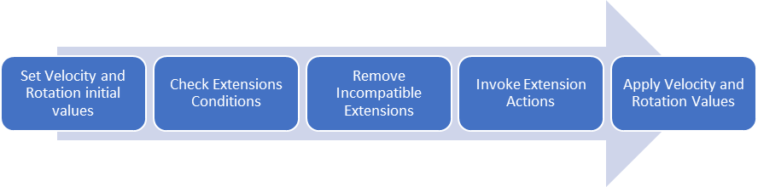
Figure 2 CharacterManager Workflow
The extensions work in 5 steps
- Set velocity and rotation initial values, to let the extensions to update them. These values will be updated through NewVelocity and NewRotation properties
- Check extension conditions. These are the basic conditions needed to let an extension work. For example, CharacterJump condition needs the jump order plus be on ground.
- Remove incompatible extensions: In some cases, we want some extensions not to work at the same time. For example, it is possible that we don’t want to let the player to change its direction when it is falling.
- Invoke extension actions: perform the changes to NewVelocity and NewRotation to let the player to move. They also provide feedback through the configured events we had.
- Apply Velocity and Rotation Values: It finally updates the Character Controller.

Extensions

Character Camera
It controls the camera rotation, through a control point located in the character. It is though to work through Cinemachine, but it is not needed, but it will give you extra work to implement a correct camera, so I don’t recommend it.

Attributes
- IncompatibleExtensions(TPC.CharacterExtension[]): List of incompatible extensions
- ConfigScriptable(CharacterScriptableCamera): the camera config file. It attributes are:
  - TopClamp(float): Highest rotation angle of the camera
  - BottomClamp(float): Lowest rotation angle of the camera
  - CameraAngleOverride(float): Vertical rotation offset of the camera
- CinemachineCameraTarget(GameObject): the target it follows

Properties
- CurrentDeviceMouse(bool): Needed to differentiate how works the camera when the info comes from a mouse than from a gamepad, screen, etc.
- Look (Vector2): the input rotation value.

Character Walk Run
That extension manages the basic horizontal movements: to walk, to run, and to rotate.

Attributes
- IncompatibleExtensions(TPC.CharacterExtension[]): List of incompatible extensions
- ConfigScriptable(CharacterScriptableWalkRun): the config file. It attributes are:
  - SlowWalkSpeed(float): walking speed. Minor speeds than this will provide feedback though to change the velocity of the animation
  - WalkSpeed(float): standard walk speed
  - SprintSpeed(float): running speed
  - RotationSmoothTime(float): affects how smooth the rotation changes. 0 means instant changes. 1 means completely slow. These values will affect how the animations feels.
  - SpeedChangeRate(float): how fast the speed animation changes. Smaller values mean small changes in the speed

Properties
- Movement(Vector2): the input movement vector
- Sprint(bool): gives info related the character is running or not

Feedback Events
- SetDirectionalSpeed(Vector2): provide cartesian info related the speed, divided in two components, based on the direction the character is moving to versus the rotation of the character.
- SetMotionSpeed(float): Provides information related the animation speed

Character Gravity
That extension manages the player gravity. It is needed to control the player not to float.
By default, we are setting that CharacterWalkRun is incompatible with this extension. It means that when the player is falling you cannot control either the speed or the rotation of the character. If you don’t want your game to work like this, you only need to change the configuration.

Attributes
- IncompatibleExtensions(TPC.CharacterExtension[]): List of incompatible extensions
- ConfigScriptable(CharacterScriptableGravity): the config file. It attributes are:
  - Gravity(float): the gravity itself

Feedback Events
- SetGrounded(bool): provides info regarding the player is grounded or not

Character Grounded
It is the opposite of character gravity. It provides feedback regarding the player is on floor.

Attributes
- IncompatibleExtensions(TPC.CharacterExtension[]): List of incompatible extensions

Character Free Fall
Provides info regarding the player is falling.
It is not the same as Character Gravity. It is a need from it. Gravity is a force that attract the player to the floor, but on a jump, for example, the player is going up, not down. Free Fall is on when the vertical velocity is minor than 0, so, the player falls.

Attributes
- IncompatibleExtensions(TPC.CharacterExtension[]): List of incompatible extensions
- ConfigScriptable(CharacterScriptableFreeFall): the config file. It attributes are:
  - FallTimeout(float): the offset before beginning to inform regarding the fall

Feedback Events
- SetFreeFall(bool): provides info regarding the player is falling or not

Character Edge Fall
Basic detector that the character is on the border to force it to fall from it.
It is important cause we are working with Character Controller. RigidBody has benefits from Character Controller because it is controlled by forces, but Character Controller has benefits from RigidBody because it is not controlled by forces.
It causes problems with the slopes, letting the player to float in impossible positions.
It Edge fall extension is one basic solution to this problem, but it is not the unique. Feel free to modify or implement your own.
Edge Fall has a small gizmo showing the direction it is detecting the floor on.

Attributes
- IncompatibleExtensions(TPC.CharacterExtension[]): List of incompatible extensions
- ConfigScriptable(CharacterScriptableEdgeFall): the config file. It attributes are:
  - SlideAngle(float): slide detection angle to begin to fall
  - SlideSpeed(float): how fast the player slides.

Feedback Events
- SetEdgeFall(bool): provides info regarding the player is falling from the edge

Character Jump
It provides the initial impulse to perform a jump.
Jump has two main incompatibilities: CharacterGravity (we don’t want to apply the force when we applying the initial force) and CharacterGround (ground detection when we are starting to jump isn’t usually needed)

Attributes
- IncompatibleExtensions(TPC.CharacterExtension[]): List of incompatible extensions
- ConfigScriptable(CharacterScriptableJump): the config file. It attributes are:
  - JumpHeight(float): how height the player jumps
  - JumpTimeout(float): timeout that control the timing until the next available jump

Properties
- Jump(bool): To perform the jump

Feedback Events
- SetJump(bool): provides feedback regarding the player is jumping

Character Automatic Jump
Makes the character to jump when it detects the player has enough space to perform it.
It has a complex Gizmo to show how the jump is being done.

Attributes
- IncompatibleExtensions(TPC.CharacterExtension[]): List of incompatible extensions
- ConfigScriptable(CharacterScriptableAutomaticJump): the config file. It attributes are:
  - MinVelocity(float): min speed needed to perform an automatic jump
  - WallProportionalHeight(float): proportional value to avoid jumping walls with the same exact height that the jump we are performing.
  - Layers(LayerMask): control whose layers the player can automatically jump.

Properties
- Jump(bool): To perform the jump

Feedback Events
- SetJump(bool): provides feedback regarding the player is jumping

Create your own Extensions
To create a new extension you need to create a class child of CharacterExtension.
It is the basic skeleton:
using System;

public class DemoExtension : TPC.CharacterExtension
{
protected override Type[] RecoverIncompatible() => incompatibleExtensionTypes;

protected override bool CheckConditions()
{
throw new NotImplementedException();
}

protected override void Action()
{
throw new NotImplementedException();
}
}
- RecoverIncompatible provides the list of incompatible extension types.
- CheckConditions check that the extension is following the conditions to run
- Action does the work
At the same time, we have access to several properties to help us to perform the work:
- Velocity(vector3): current velocity
- NewVelocity(vector3): the new velocity the player will have
- NewRotation(Quaternion): the new rotation the player will have
- FloorRadius(float): Floor detection radius(from characterController)
- Height(float): player height (from characterController)
- IsGrounded: info regarding the player being on ground or not
On this basic example the player will begin to dance 2 seconds later it stop moving
using System;
using UnityEngine;

[RequireComponent(typeof(Animator))]
public class DemoExtension : TPC.CharacterExtension
{
private Animator _animator;
private float time;

public new void Awake()
{
base.Awake();
_animator = GetComponent<Animator>();
}

protected override Type[] RecoverIncompatible() => incompatibleExtensionTypes;

protected override bool CheckConditions()
{
Debug.Log((IsGrounded && Velocity.x == 0 && Velocity.z == 0) + " " + time);
if (IsGrounded && Velocity.x == 0 && Velocity.z == 0) // player on ground and it is not moving
time += Time.deltaTime;
else
{
time = 0;
_animator.SetBool("DemoDance", false); // Dissable the action
}
return time > 2;
}

protected override void Action() => _animator.SetBool("DemoDance", true); // Performs the action
}

